UI Preliminary design:

We have created 5 html page for preliminary design.

Fig 1 Homepage

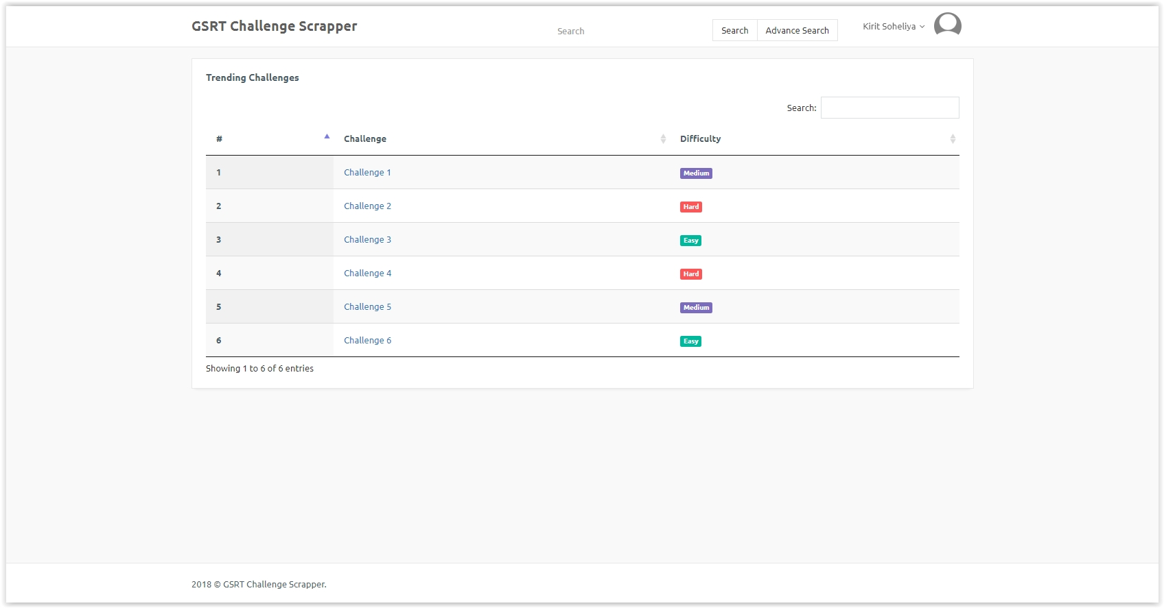

Fig 2 Register page

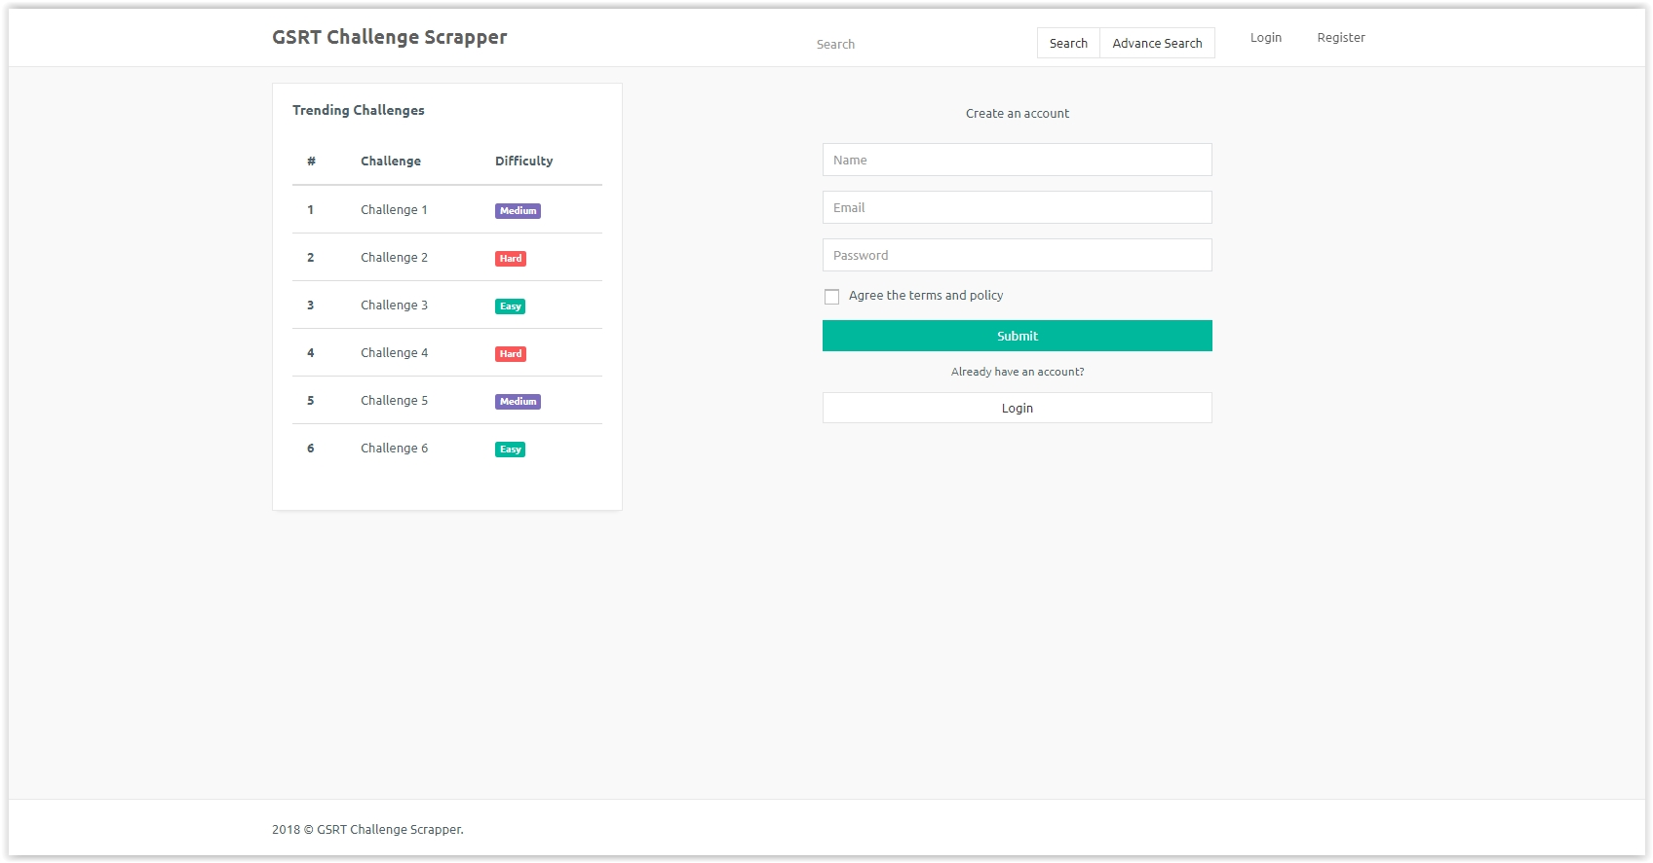

Fig 3 Login page

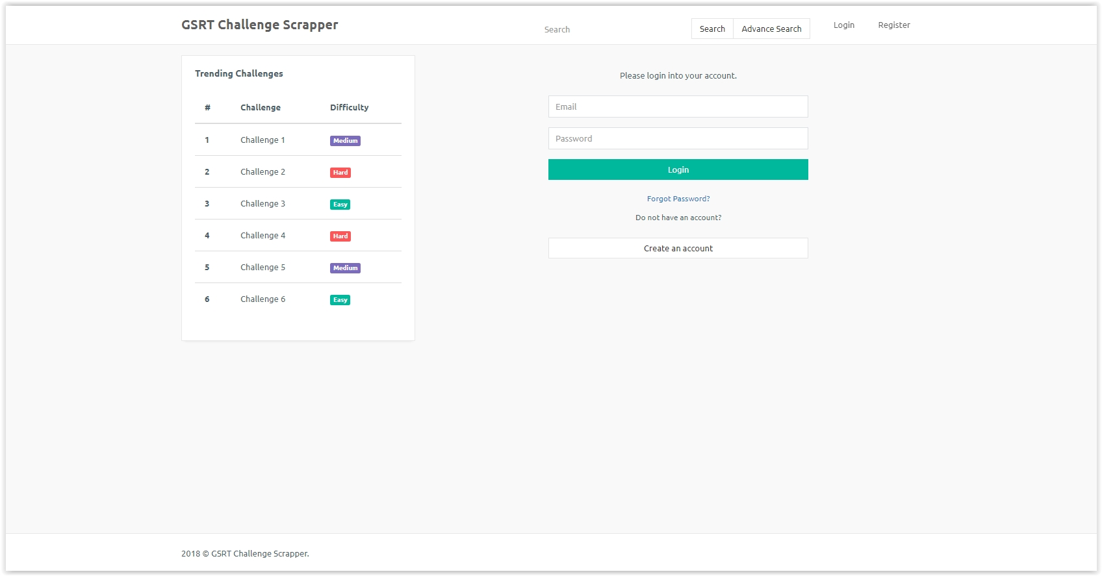

Fig 4 Challenge View page:

